SENTINENTAL inc

Leave Application System

Table of Contents

1.1 LIST OF FIGURES 2

2 Team 3

2.1 Overview 4

3 Mission 4

4 Project Schedule 4

5 Vision 5

6 Software Selection 5

6.1 Sublime Text 5

6.2 MySQL 6

6.3 Xampp 6

6.4 PhpMyAdmin 6

7 ERD 7

8 Functional Requirements 8

8.1 Inputs 8

8.2 Processes 8

8.3 Outputs 8

8.4 Data 8

9 Performance Requirements 9

10 Leave Application System Screenshots 9

11 Design and Implementation Constraints 12

12 REFERENCE LIST 13

## LIST OF FIGURES

Figure 3:1: Project Schedule 4

Figure 4:1: Process Flow Diagram 5

Figure 6:1 Entity Relationship Diagram 7

Figure 10:1- Register form 9

Figure 10:2- Sign In form 10

Figure 10:3- Apply of Leave form 10

Figure 10:5- Manager’s form 11

Figure 10:6- Admin’s form 11

# Team

Group Member: Jaco van Wyk

Email: vwykjacoj@gmail.com

Student Number: 25950665

Position: Database administrator

Skill set: Very organized, good at proofreading documents, focused, good communication skills and professional.

Group Member: Panashe Mabwe

Email: mabwepanashe@gmail.com

Student Number: 27108945

Position: Project Manager and Systems Analyst

Skill set: System Analysis, communication skills, proficient in Java and C#.

Group Member: Amukelani Maluleke

Email: amumal86@gmail.com

Student Number: 28077520

Position: Solution Architect

Skill set: Analysis, research and database modelling.

Group Member: Chiraag Maharaj

Email: chiraagmah@gmail.com

Student Number: 25045695

Position: GUI- Front end design and functionality

Skill set: Proficient in programming (multiple programming languages). And research.

## Overview

Sentinental Inc. plan is to develop a Leave Application system that makes use of a dynamic website connected to a database. Furthermore, with specification by the client, managers will be able to approve or reject leave applications and add an additional reason for the choice taken.

# Mission

Sentinental Inc. mission is to provide a reliable and satisfactory system that surpasses the client’s expectations. In addition to this, a system with a secure database and queries executed within milliseconds while implementing various security measures such as:

* Prevention of malicious user input
* Safe error messages
* Secure database access
* Guard against Denial-of-Service attacks

# Project Schedule

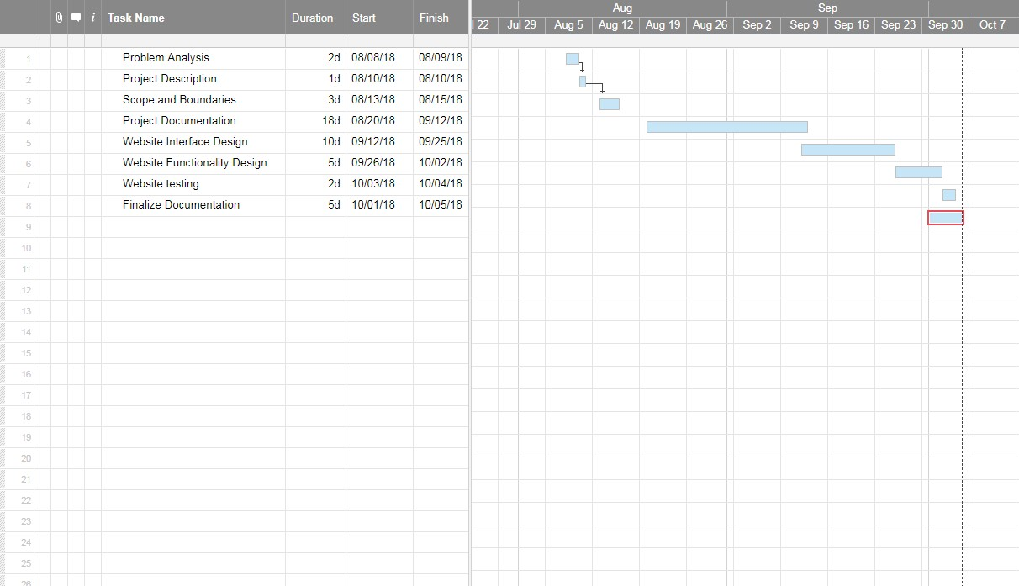

Figure 3:1: Project Schedule

# Vision

Sentinental Inc. vision is to become a trusted software developer in the industry and foresee ourselves working on similar projects such as the Leave Application system.

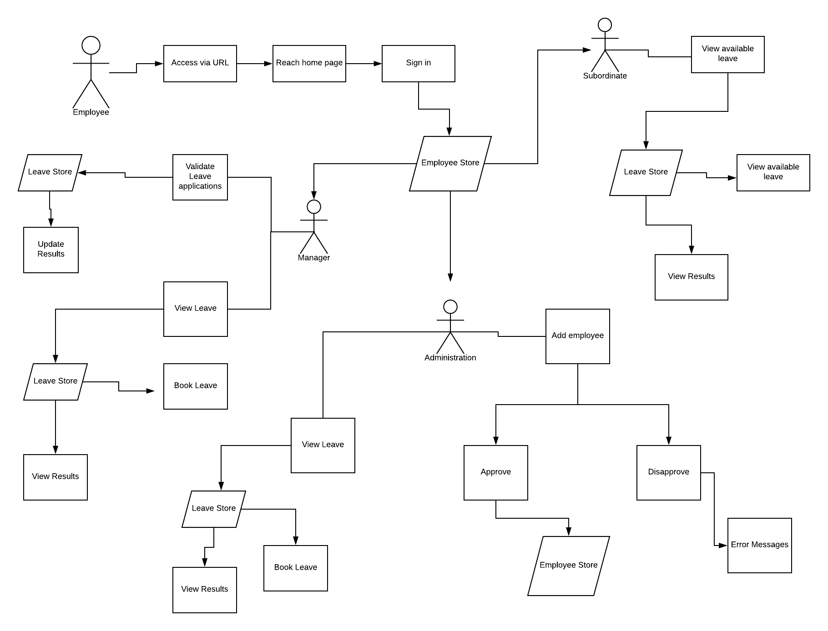

Figure 4:1: Process Flow Diagram

# Software Selection

## Sublime Text

The code editor used to program the system and below are few of the advantages:

* Multiple cursors great for multiple edits and inserts
* Code preview
* Requires less resources

## MySQL

The selected Database Management System for this system due to it being free to use, stable, reliable and powerful solution with sophisticated features such as:

* Data security
* High performance
* Optimization of queries

## Xampp

The web server solution we used in our system due to its portability and various benefits such as:

* Simple compatibility with PHP
* Highly secure
* Open source

## PhpMyAdmin

The program we used in our system regarding the database management of the website due to its advanced features such as the synchronization of databases and many more including:

* Open source tool
* Can easily modify databases using the GUI provided
* Execution of complex queries

# ERD

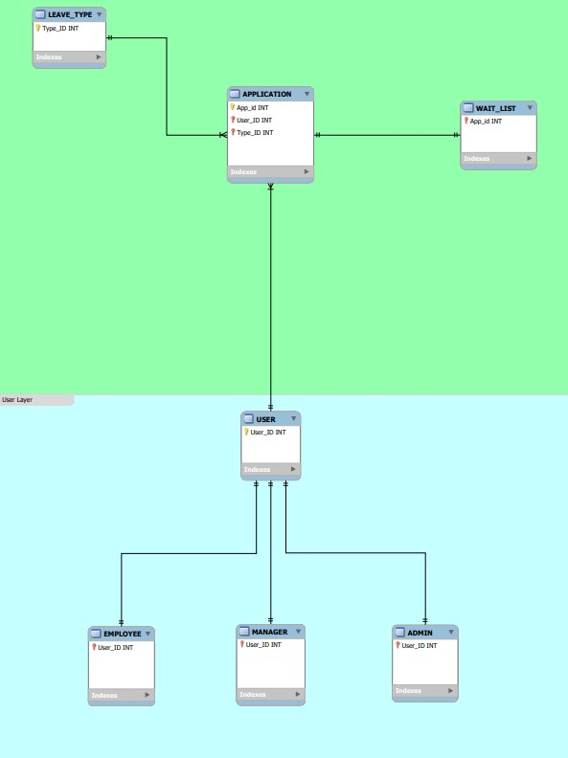

Figure 6:1 Entity Relationship Diagram

# Functional Requirements

## Inputs

The following inputs are needed: employee's department, name, password, email, gender, age, and job, date employed enabling the admin to add a new user to the database.

Application leave types can be created by the admin and must specify the following attributes: leave type, name, description, maximum amount of day before the leave day caps and the rate/speed at which this leave type adds a new day (a ratio of 1 = one day is returned/added of every year that passes; 0.5 = one day per every 2 years added; 12 = one day added per month, etc.).

A user can apply for a leave application but must specify the following: user_id, the type of leave wanted, start date and the amount of days of leave they want to take.

A manager from the same department and of higher rank can approve or disapprove a leave application.

Input into database needs to be safe and secure.

## Processes

Newly created leave applications need to be added to a pending list so a person with a higher rank can approve or reject the application, thus removing it from the pending list.

Application need to be created and stored as well as be able to cancel an application they created.

## Outputs

An application needs to be approved or denied by the manager. The manager can view all or single employee information, a list of all leave types, a current user leave balance and history of approved, rejected and pending application created.

## Data

Admin user needs to be added into database to create new employees and leave type for leave applications.

Created Leave applications and Users data should be stored in the database so it can be viewed later and edited if needed.

A database entity that holds references to newly created leave applications that have not been approved or rejected yet. This makes it easier to find applications that needs approval for a specific manager.

An entity that holds information of all existing departments and ranks them from 0 upward (0 being the highest rank, ex. CEO, and the highest number being the lowest rank of the whole business).

# Performance Requirements

The system should meet the following requirements:

* Execute users’ queries in a timely manner
* Produce accurate and relevant information
* Possess high data integrity

# Leave Application System Screenshots

Registering

This is where the Admin will create an employee by providing the employee number as well as other attributes depicting the employee. The purpose of this register page is to add the employee to the database and basically in the system thus enabling the manager and admin to view the employee profile. Upon completion of this from the user will be taken to the log in form.

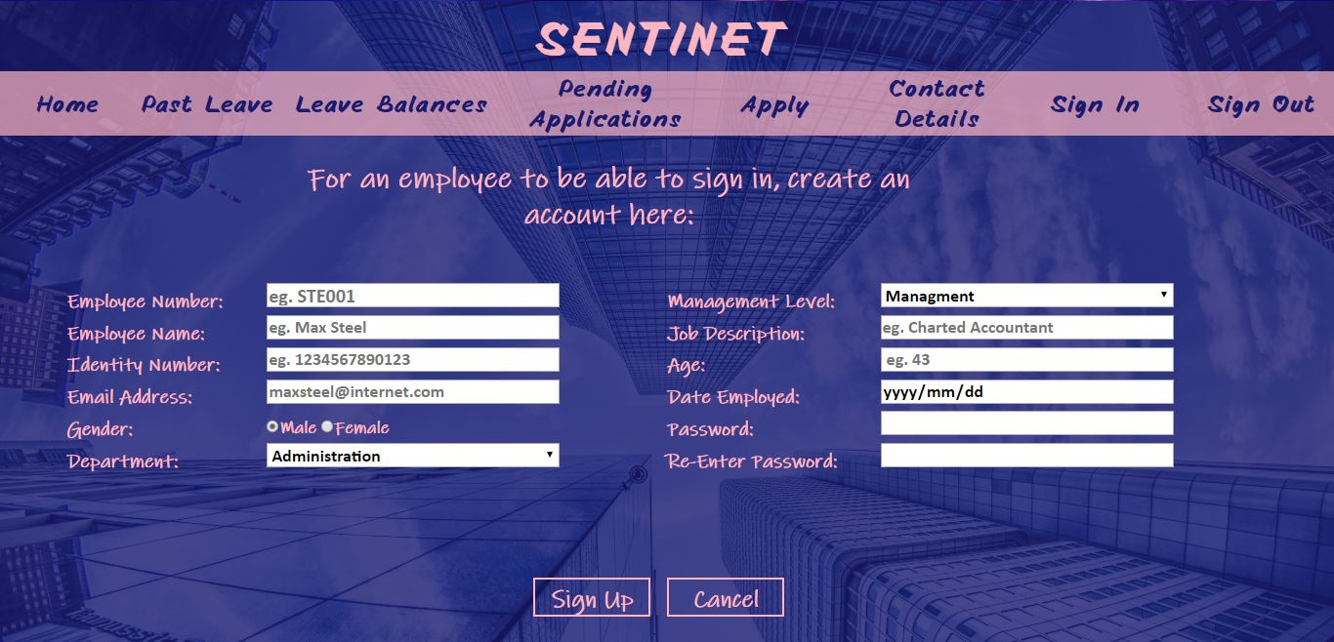

Figure 10:1- Register form

Sign in

The employee logs onto the system via this page by entering their unique employee number and password. Upon entering valid credentials, the system is able to identify what type of employee the user is and the privileges that employee possess.

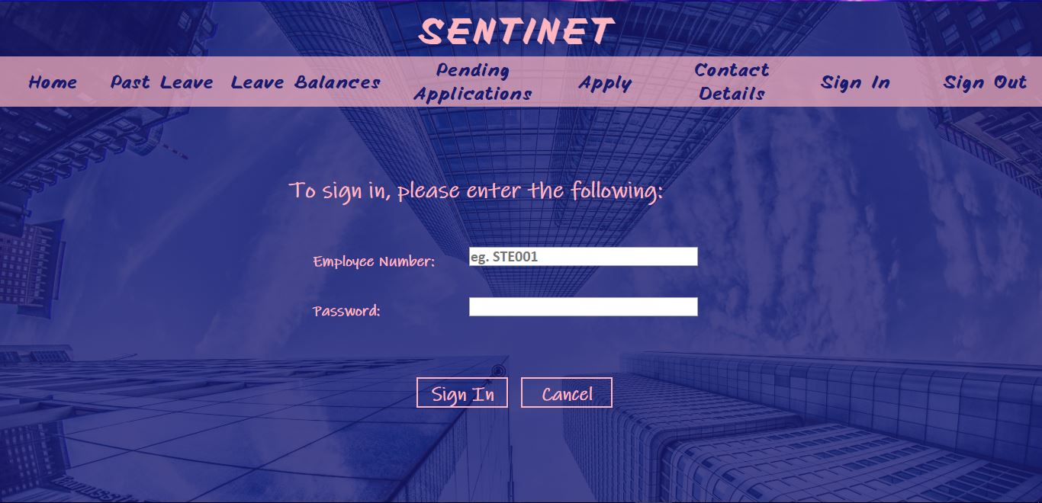

Figure 10:2- Sign In form

Leave Apply form

The employee specifies the type of leave they are applying for as well as the period

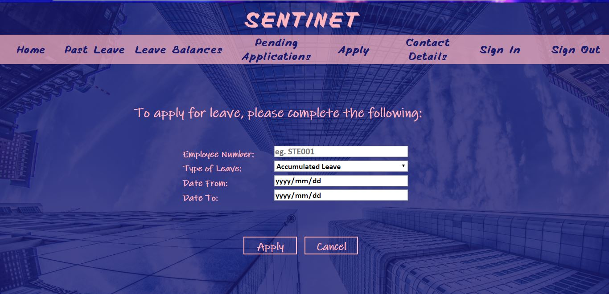

Figure 10:3- Apply of Leave form

Manager’s form

The manager is able to view pending leave applications via this form and can either approve or disapprove an employee’s leave application which will reflect on the employee’s profile as well as the database.

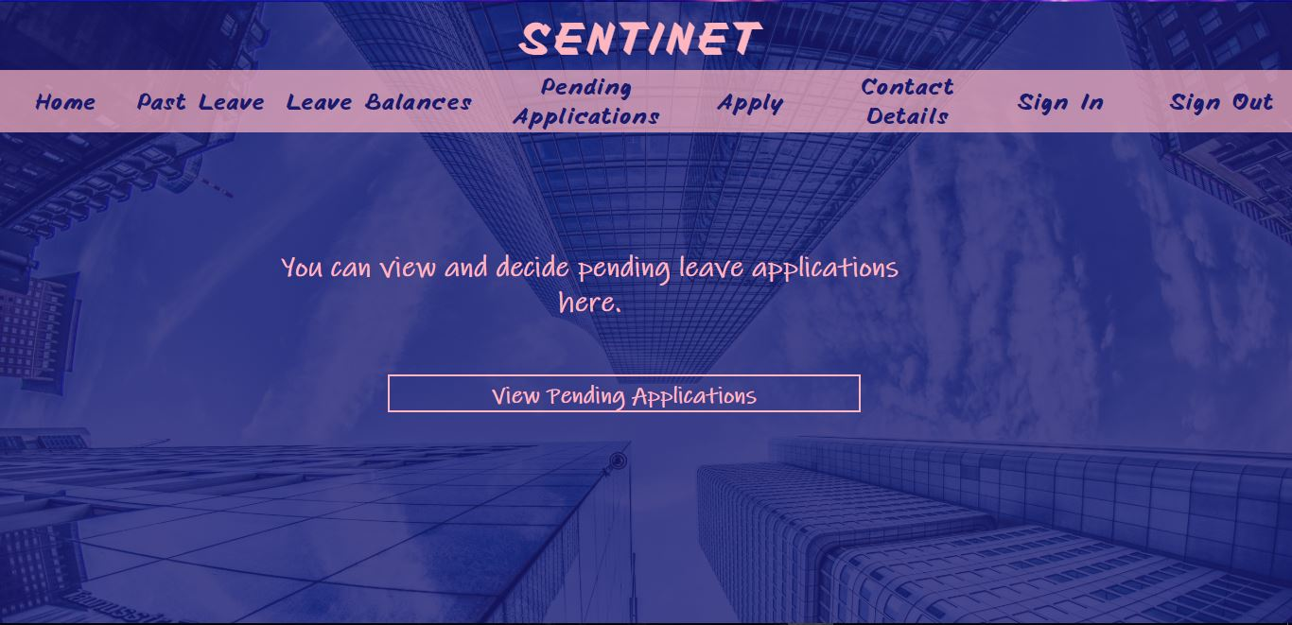

Figure 10:5- Manager’s form

Administrator form

The admin has the privilege of adding, updating employee’s details as well deleting employees from the system and basically database. Furthermore, the Admin can also view the amount (balance) of leave days an employee has.

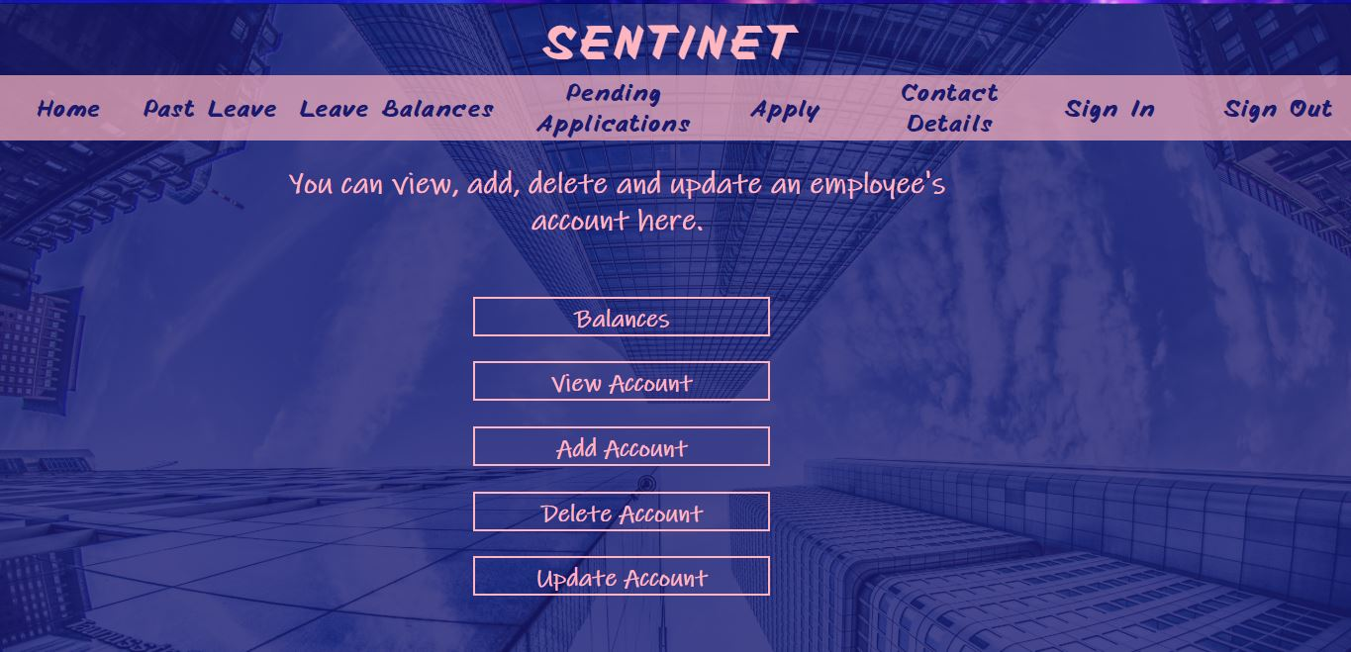

Figure 10:6- Admin’s form

# Design and Implementation Constraints

* Leave Application system will on run on devices with supported internet browsers such as Google Chrome and Fire Fox.

# REFERENCE LIST

Beranson, T. (2016). *8 Major Advantages of Using MySQL*. [online] Datamation. Available at: https://www.datamation.com/storage/8-major-advantages-of-using-mysql.html [Accessed 8 Oct. 2018].

Bernheim, L. (2017). *Things You Might Not Know About phpMyAdmin: The History, Features, and Code Behind the Popular App for Administering MySQL Databases - HostingAdvice.com*. [online] HostingAdvice. Available at: https://www.hostingadvice.com/blog/why-phpmyadmin-best-db-admin-tool-for-business/ [Accessed 8 Oct. 2018].

Elliot, T. (2014). *13 reasons to use of Sublime Text over Dreamweaver*. [online] Tomelliott. Available at: https://tomelliott.com/sublime-text/advantages-sublime-dreamweaver [Accessed 8 Oct. 2018].